Kol simcha torah gazette
For parshas emor 5784
Volume 8 Issue 36 (Whole #394) 10 Iyar 5784/ May 18, 2024
Printed L’illuy nishmas Nechama bas R’ Noach, a”h

For a free subscription, please forward your request to keren18@juno.com
Past emails can be found on the website ShabbosStories.com under Brooklyn Torah Gazette

The Queen Who Converted to Judaism: The Incredible True Story of Helena
By Avi Abrams

How Queen Helena saved the people of Jerusalem and beautified the Temple. Long live the queen who converted to Judaism.

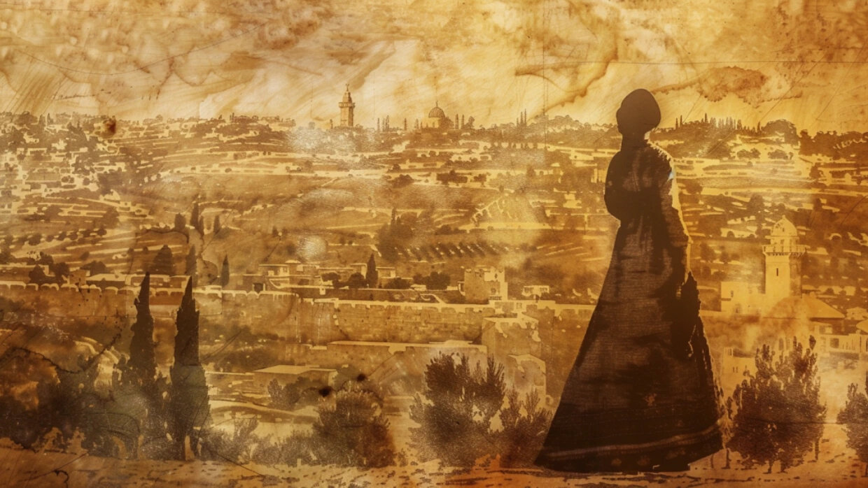

You might have heard of Queen Helena, the mother of Constantine, who had a significant influence on introducing Christianity to the Roman Empire in the 4th century. But around 300 years earlier, there was another Queen Helena who had a significant influence on introducing Judaism to a long-lost kingdom by the name of Adiabene.
Adiabene was a semi-independent country located in what is now the Kurdish regions of northern Iraq. It ruled the area during the Greco-Roman period and was often a vassal state caught between the competing powers of Persia in the east and Rome in the west. It ruled over Nineveh (the city visited by the prophet Jonah centuries earlier) and its capital was called Arbela (modern day Erbil, the most populous city in today’s Iraqi Kurdistan).

One of the Wives of King Monbaz I
During the early first century, Monbaz I ruled Adiabene along with several wives, one of whom was Queen Helena. Although Monbaz had older children from his other wives, the preferred heir to the throne was one of Helena’s sons, namely Izates II. When the half-brothers of Izates learned that he was in fact the designated crown price, Helena feared for his safety and sent him southwards to the Arab kingdom of Characene (today located in southern Iraq near the Persian Gulf), which was allied with Adiabene at the time. It was there, in the capital of Charax-Spasinu that he was taken in by King Abinergaos and married his daughter, a woman named Symachos.
Jewish communities had flourished in the neighboring lands of Babylonia and Persia for centuries by this point (their ancestors having been deported there from ancient Israel by Nebuchadnezzar in the aftermath of the destruction of the First Temple in 586 BCE). Situated at the intersection of international trade routes, the people of Characene would have been frequently exposed to Jewish merchants and pilgrims travelling through their territory on their way to or returning from Jerusalem.

A Jewish Sage Who Became a Mentor to Prince Izates
One of these merchants was a Jewish sage by the name of Hananiah (also known by his Greek name Ananias). While visiting the royal palace in Charax-Spasinu, he came into contact with Izates. Inspired by the faith and wisdom of the Jewish religion, Hananiah became his new mentor.
Meanwhile, back in Adiabene, Queen Helena came into contact with a Jewish sage of her own, Rabbi Eleazar from the Galilee. She too developed a strong affinity for Judaism and learned Jewish teachings from the great rabbi on a regular basis. Following the death of King Monbaz, Izates was called back from Characene to rule over his people in Adiabene.
After accepting the throne and exiling his jealous half-brothers from the country, Izates, his mother Queen Helena, and her other son Monbaz II embarked on a full Jewish conversion under the guidance of Rabbi Hananiah and Rabbi Eleazar of Galilee. The royal family of Adiabene converted to Judaism around 30 CE, but for the most part, kept it a private matter.
By 39 CE, rumors circulated in neighboring kingdoms about the conversion to Judaism of King Izates. This was greatly resented by Abias, king of the Arabs in the south, as well as the Parthians in the east, who declared war on Adiabene. While Izates led his army out of Adiabene to confront the various military threats, Queen Helena made a vow that if her son would return safe from the battlefront, she would become a Nazarite for 7 years.

Brought a Nazarite Sacrifice to Jerusalem
Upon his return, she did just that, which meant abstaining from wine, not cutting her hair, and having no physical contact with a grave or corpse. The Nazarite law, as stipulated in the Bible, requires the person who took the vow to bring a sacrifice to the Temple in Jerusalem at the conclusion of the oath period. In 46 CE, at the end of the seven-year commitment, Helena embarked on her first trip to Israel (known at the time as Judea).
Arriving to the Temple and explaining her story to the Jewish scholars of Jerusalem (the House of Hillel), her sacrifice could not be accepted. It was explained to her that any Nazarite vow could only be fulfilled while in the Land of Israel. Being a pious convert, Queen Helena took upon herself to fulfill the conditions of the oath and become a Nazarite again for an additional seven-year period, but this time in the Jewish homeland. What started out as a short visit to Israel turned into a nine-year adventure (she stayed on for an additional two years after her vow expired). They were the most intellectually stimulating years of Helena’s life.

Distribute Food to Poor Jewish Families in the Holy City
After settling into Jerusalem, it became apparent that something wasn’t right. The city had been hit hard by famine and the people of Jerusalem lacked funds to import food from afar. Every day, people were perishing in the streets from malnutrition. This was no joke. For years, Helena was benefitting from the wisdom and inspiration of Judaism. Now was Helena’s opportunity to give back to the Jewish people. She took the initiative and sent a team of her servants to Alexandria, Egypt to purchase grain and another team to Cyprus to purchase dried figs and personally imported the cargo on her own expense. She had the supplies distributed to all the poor families of Jerusalem and saved the city from starvation. Her reputation rapidly grew and she became a beloved celebrity in the holy city.
Now that she took care of the people, it was time to take care of herself as well. Being a queen of course, renting a flat just wouldn’t do. Josephus Flavius (aka Yosef ben Matityahu), the famous Jewish historian who also lived in Jerusalem during this time period, described the magnificent palace that Helena built for herself just south of the Temple Mount in a neighborhood of Jerusalem known as “the Lower City”. It had that name because it was on a lower elevation of the city (bottom of the hill), but also because it was where the lower classes lived, the poor of the city, lower income people, and the homeless.
Of course, Queen Helena could have built her palace in the Upper City, amongst the elites and near the grand palace of King Herod. But she chose to create an open house, using her wealth to provide the poor of Jerusalem with free meals, especially on the Sabbath and festivals.
In 2007, during excavations of the Givati parking lot outside the City of David (not far from the Western Wall), archaeologists uncovered the palace of Queen Helena. Two floors could be identified along a wall 46-feet long and 16-feet tall. It also included ritual baths, pottery, frescoes, storage rooms, hallways, living quarters, and coins dated to the mid-1st century.

Helena of Adiabene.
Helena’s contributions were not limited to the poor. Her donations included unique gifts to the Temple in Jerusalem. The most famous example was a gigantic shiny golden candelabra that was hung from the ceiling at the entrance to the sanctuary. Since the entrance to the Temple faced the east, when the sun would rise over the Mount of Olives, it would reflect off the golden candelabra and people would immediately know it was time to say the Shema prayer without having to turn backwards. Without the candelabra, people would need to turn their backs to the Temple in order to gaze at the sun, which to an outside observer may be misconstrued as an idolatrous practice since sunworshippers were common at that time.
It’s for this reason that even today, many synagogues around the world have a hanging candelabra, in honor of Helena. Other donations included a gold tablet inscribed with the Biblical law for suspected adulterers as well as gold handles that were attached to various vessels used in the Temple’s Yom Kippur rituals.

Spent Nine Years Living in Jerusalem
In 55 C.E. after spending 9 years in Jerusalem, Helena was called back to Adiabene to attend the funeral of her son Izates II, who unexpectedly passed away at the age of 55 after ruling his kingdom for 24 years. Helena, who was in her 70s by this point, was grief stricken and she passed away shortly after her arrival in Adiabene.
Monbaz II, the other son who converted to Judaism now took the throne. He ordered the remains of his mother and brother to be buried outside Jerusalem in a tomb that Helena had earlier constructed for the royal family prior to her death. In those days, it was customary for kings and queens to build their own tombs during their lifetimes that would usually house both their remains and that of their offspring.
The classical rock cut tomb included a triple pyramid rooftop, which was probably meant for Helena and her two sons, Izates II and Monbaz II. Tombs with pyramid rooftops were common among Jewish kings and high priests towards the end of the Second Temple period and are still visible today in the surroundings of Jerusalem’s old city. Josephus, who lived in Jerusalem at the same time as Helena, described the location of her tomb as being “three furlong from the city”, which in today’s terminology means around half a mile.
In 1863, French archaeologist Louis Félicien de Saulcy conducted an excavation at a monument known as “Tomb of the Kings” located about half a mile north of Jerusalem’s old city walls. It was traditionally believed to be an ancient tomb for the Biblical kings of Judah, but research at the site in fact dated it to the first century, the time period of Helena, hundreds of years after the Biblical kings. Five sarcophagi were discovered there including one, which reads in Aramaic “Tzara Malchata – צרה מלכתא”, meaning “our mistress the queen”.

The Tomb was Smuggled to Paris
Inside was found a body covered in a gold embroidered shroud. De Saulcy managed to smuggle the sarcophagus out of the country and shipped it to Paris where it remains today on display in the Louvre Museum. The tomb was acquired by the French government in 1886. Through negotiations with the State of Israel, the tomb site has been open to tourism on a limited basis since 2019.
Queen Helena saw the Temple and ancient Jerusalem at the height of its glory just 15 years before its destruction by the Romans. Her acts of piety are mentioned in the Talmud and the discovery of her tomb serves as an eternal edifice for her memory. Long live the queen who converted to Judaism!

Reprinted from this week’s website of aish.com

******************************************************************

The opposite of profaning G-d’s name is the sanctification of G-d’s name. When a Jew performs a mitzva (commandment) with devotion, and with pure intent, he is sanctifying G-d’s name. When a Jew behaves in such a manner that only good things are heard about him, that too is a sanctification of G-d’s name. However, the opposite is also true. (Rambam)

Reprinted from the Parshas Emor 5783 edition of L’Chaim Living

Rav Avigdor Miller on
How a Ben Torah Should
Try to Solve Social Problems

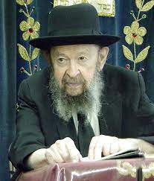

QUESTION: To what extent should a ben-Torah give away time from his learning in order to deal with air pollution and other problems that we are facing?

ANSWER: It depends on which problem. You can’t cover all the problems with one blanket; but since you mentioned air pollution I’ll tell you how to deal with that. I’m going to tell you now, how to solve the problem of air pollution.
In the morning, as you go to davenen or back from davenen, so breathe deeply and think what the Medrash says: – For every breath you have to say a hallel. Breathe deeply from the Brooklyn air and enjoy that cocktail. Especially with the fragrance of the spring blossoms, and the morning sunshine. Enjoy it and forget about all the stupid propaganda that is being made lately. Because you have to know that the whole business of pollution is propaganda that’s devised for the purpose of making a disturbance in the country. People don’t understand that – they’re victims of the propaganda.
Of course, it’s better to have mountain-air than polluted air. But the problem is by no means anywhere near what they’re making of it. The whole pollution business is a smoke screen. The real polluters are the ones who talk about pollution. Look at them. Look at the people who talk about pollution. They are the ones who want to kill babies. They’re the ones! It’s always those! The ones who are screaming and howling about pollution, they’re the ones who approve of abortion! The ones who scream about pollution are also the ones who are hinting that it’s a good thing to introduce euthanasia.
And you’ll also find that it’s the agitators, the Vietnam protestors, who want to legalize marijuana. It’s this same gang that is always talking about pollution. Of course, sometimes an innocent victim is duped – an innocent person is also pulled onto their side. But generally, it’s the pseudo-liberals who raise the green and black flag of pollution. And you have to know that it’s not for us – it’s not our way.
Our way of dealing with pollution is by learning how to enjoy the air. Breathe deeply and enjoy the air. People aren’t doing that. It’s a lot of fun when you learn how to breathe deeply and enjoy the air. Breathe deeply! That’s my answer to your question about pollution. How much time should you give to the problem of pollution? No time at all.

Reprinted from the Emor 5783 email of Toras Avigdor, based on the teachings of Rav Avigdor Miller, zt”l.

You shall count for yourselves from the day after the Shabbat, from the day that you brought the Omer of the waving; seven complete weeks shall they be. (Lev 23:15)
This verse discusses the laws concerning Sefirat HaOmer - the counting of the Omer which takes place between Passover and Shavuot. Rashi explains that “from the day after the Shabbat” refers to the day after the festival, i.e. the second day of Passover. He further explains that the word “complete” teaches us that one begins to count from the evening (the second night of Passover) or else the weeks are not truly complete. The word “u’sefartem - and you shall count” is from the same root as the words “sapphire” and “bright” as if to say, “Work on ‘yourselves’ until you are shiny and bright.” (The Maggid of Mezritch)
In counting sefira, the days between Pesach and Shavuot, we learn about the importance of time. Counting the days before Shavuot, the day on which we received the Torah, is a preparation for receiving the Torah, which emphasizes the value of time. Every Jew is obligated to occupy as much time as possible in Torah study, and not waste time that could be used for this purpose. (Likutei Sichot)
We Can’t Understand Why
G-d Allows Things to be
Out of Control in Our Lives
From the Teachings of the Lubavitcher Rebbe
Rabbi Menachem Mendel Schneerson, Zt”l
Adapted by Rabbi Eli Touger
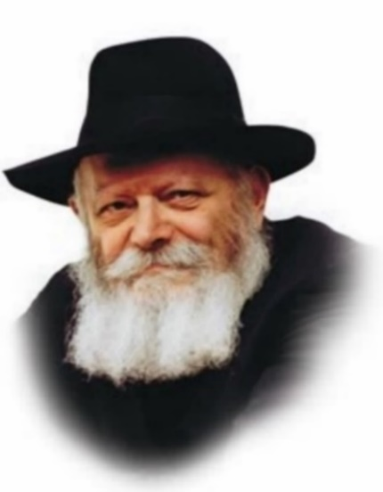

In this week’s Torah portion, Emor, we read about the care of newborn animals. “When an ox, a sheep, or a goat are born, for seven days it should remain under its mother’s care, from the eighth day and on it will be acceptable as a sacrifice to G-d.”
Later, in the same paragraph, the Torah commands us, “And you should not desecrate My Holy Name, that I may be sanctified amongst the children of Israel...”.
What could possibly be the connection that brings these two laws together?
The newborn animals are symbolic of our emotions that our intellect, the mother, gives birth to. Rather than allow your emotions free reign, “Seven days it should remain under its mother’s care.” Allow your mind time to develop the emotion before expressing it.
This is especially important to remember in situations that are out of our control, meaning that they are clearly and directly from G-d. Especially when it is impossible to make sense of. Here we need to let our thought process the notion that G-d knows what and why He does these things. Our job is to find a way to sanctify G-d through these events, so that it changes us in a positive way.

Reprinted from the Parshas Emor 5783 edition of L’Chaim Living, a publication of the Lubavitch Youth Organization in Brooklyn. Adapted by Rabbi Yitzi Hurwitz from the teachings of the Lubavitcher Rebbe, yitzihurwitz.blogspot.com. Rabbi Hurwitz, who is battling ALS, and his wife Dina, are emissaries of the Rebbe in Temecula, Ca.

Rabbi Berel Wein on
Parshat Emor 5784

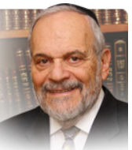

The beginning part of this week’s parsha refers to the special laws and status regarding kohanim – the descendants of Aharon. It is common knowledge that a study based on the DNA samples of many current day kohanim reveals a common genetic strain amongst a considerable number of those who participated in the study. This strain is found to be common even amongst people who live in different areas of the world, separated by thousands of miles and centuries of differing ethnicities.

The jury is still out whether these DNA findings have any halachic validity and as to what exactly these findings prove. Over the centuries of Jewish life, the kohanim have fiercely protected their lineal descent from Aharon and zealously guarded their status of legitimacy as being kohanim. Kohanim are held in high regard in the Jewish world and are entitled to certain special privileges and honors in the Jewish religious society.

Though it seems that it is permissible for a kohein to waive some of those privileges if he so wishes, preferred behavior dictates that he not do so. The status of the kohein is to be preserved as a remembrance of their special role in the Temple services in Jerusalem. But in a deeper sense, it is to be preserved to remind us of their special mission “to guard with their lips knowledge and to teach Torah to those who request it.”

They are to be a blessing to the people of Israel and they are commanded to, in turn, bless the people of Israel. Blessed are those that are commanded to bless others. Thus, the status of a kohein is representative of all that is noble and positive in Jewish life and tradition – knowledge, Torah, grace, security and peace. The question of ersatz kohanim is discussed widely in connection with halachic decisions.

Not every person who claims to be a kohein is really a kohein. Since true pedigrees are very difficult to truly ascertain today, the halacha adopts a position that who is really a kohein is a matter of doubt. Great rabbinic decisors, especially in the United States, have often, in cases of dire circumstances, “annulled” the kehuna of an individual.

In the confusion of immigration into the United States at the end of the nineteenth and the beginning of the twentieth centuries, there were people who disguised themselves as kohanim in order to earn the monies of pidyon haben – the redemption of the first-born son from the kohein. These people were charlatans, but many other simple Jews assumed that they were kohanim as well, without any real proof of the matter. Even tombstones that declared that one’s father was a kohein were not to be accepted as definitive proof of the matter. Therefore, the DNA results are most interesting and provocative.

The halacha has not yet determined with certainty the trustworthiness of DNA results in matters that require halachic decision. Therefore, it is premature to speculate whether DNA testing will ever be used as a method of determining one’s true status as a kohein. Meanwhile the kohanim should retain their tradition of pedigree to the best of their abilities.

Shabbat shalom.

Reprinted from the current website of rabbiwein.com
11 Facts About the
Crusades and the Jews
By Yehuda Altein

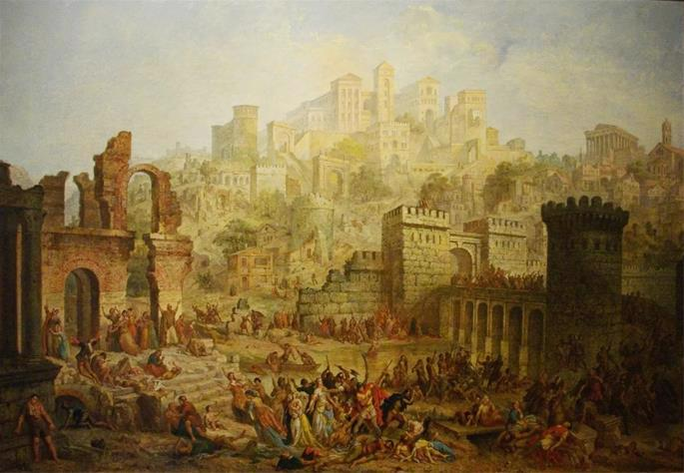
Massacres of the Jews of Metz during the First Crusade. Auguste Migette

The Crusades were a series of Christian efforts to wrest Jerusalem from the Muslims. On their way, the frenzied mobs wreaked havoc on numerous Jewish communities in medieval Western Europe. Read on for 11 facts about this horrific era of history, which set the precedent for countless Antisemitic acts carried out since then in the name of religion.

1. The Crusades Were “Holy” Wars
The Crusades were a series of “holy” wars carried out by European Christians primarily in the 11th-13th centuries. Their stated goal was to free Jerusalem from the Muslims, whom they viewed as infidels, and establish a Christian kingdom there. On their way to the Holy Land, the zealous mobs pounced on the opportunity to rid themselves of the “infidels” in their midst—the Jews, viciously decimating many Jewish communities.

2. They Were Initiated by Popes
Far from being a grassroots movement, the Crusades were called for and directed by the Popes themselves. Although they did not openly advocate for the murder of Jews, many church leaders were quick to turn a blind eye when these atrocities did occur.

3. The Crusaders’ Motives Were Far From Sacred
Politics played a large role in the papal decision to launch a crusade. For centuries, the Church had been at odds with the monarchs of Western Europe, each side jockeying for power. What greater strategy to undermine royal authority than to call for a religious war, uniting the masses under the Pope’s banner? As for the soldiers, they joined the Crusades as an easy way to get rich off plunder—and to obtain the Church’s promise of eternal salvation and automatic forgiveness for all their sins.

4. Soldiers Were Joined by Mobs of Peasants
Initially, the plan was for the Crusades to consist of armies of professional soldiers on an organized expedition to the Holy Land. But as religious hysteria spread throughout Europe, more and more peasants and commonfolk joined the Crusaders’ ranks. With tens of thousands of people joining the cause, any sense of order and discipline had now disappeared, and the masses, spurred by religious zeal and natural greed, felt free to act as they wished. In many cases, these mobs overwhelmed the forces of local rulers who attempted to protect their Jewish subjects.
5. The First Was the Worst
Jews were pillaged and murdered during each of the first three Crusades. In terms of casualties and mass destruction, the First Crusade surpassed the others. Initiated in 1096 by Pope Urban II, the victims of this crusade included Jewish communities in France, Germany, and Jerusalem.

6. The Rhineland Was Hit Hard
After wreaking havoc on various communities in France, the armies of the First Crusade made their way to Germany. What followed was a bloodbath in the three great Jewish communities of the Rhineland: Speyer, Worms, and Mainz.
Throngs of Crusaders entered Speyer on Shabbat, 8 Iyar, where they proceeded to murder 10 Jews for refusing to embrace Christianity. The rest of the community was saved thanks to the intervention of the local ruler.
The Jews of Worms and Mainz did not fare as well. When news of the onslaught reached the community of Worms, many Jews barricaded themselves in the ruler’s castle for protection. The mob arrived there on 23 Iyar, finding easy prey in the Jews who had remained in their homes. Seven days later, the Crusaders penetrated the fortress and murdered the Jews inside. By the time they had left, the bulk of the community—800 souls in all—had been ruthlessly slaughtered, with the rest forcibly baptized.
The Jews of Mainz similarly sought safety in the ruler’s castle, only to have the Crusaders storm the walls on 3 Sivan, resulting in the deaths of the 1,300 Jews hiding inside.
These cities were the first of many in Germany attacked by the frenzied mobs, who murdered the Jewish inhabitants, ransacked their homes, and desecrated their Torah scrolls.¹

7. Many Jews Sacrificed Their Lives Rather Than Convert
In many instances, the Crusaders promised to spare the Jews’ lives if they would agree to convert. The vast majority categorically declined the offer and proudly chose death over denouncing their faith. In some cases, Jews took their own lives and those of their children to prevent them from being forcibly baptized.²

8. Rabbeinu Tam Survived the Second Crusade
The Second Crusade, launched in 1146, inflicted further losses on the Jewish communities of France and Germany. In one instance, bloodthirsty crusaders entered the home of Rabbi Yaakov ben Meir, commonly known as Rabbeinu Tam, in the French town of Ramerupt. After pillaging his home, they stabbed him multiple times in the head. Miraculously, at the last moment, he was saved thanks to the intervention of a passing nobleman.³

9. English Jews Suffered From the Third Crusade
In 1189, Richard the Lionhearted was crowned king of England and announced his intent to join the Third Crusade. This declaration fanned anti-Jewish sentiment among the populace, who proceeded to target several English Jewish communities. Notable among them was the Jewish community of York, where 150 Jews, under siege at Clifford’s Tower, met a tragic death.⁴ Although there is no reliable source for the custom, Jews traditionally have not lived in York, or even spent a night there, since the massacre.

10. They Set a Dangerous Precedent
The total number of Jewish casualties from the First Crusade is estimated at about 10,000—a far cry from some of the later tragedies our people underwent (most notably the Holocaust). However, the population of Europe in 1096 was less than 10% of what it is today, and the numbers given above represent entire communities that were decimated.
More importantly, the Crusades marked the first organized massacres of Jews in the Christian world. While medieval Jews had been persecuted before, those events were sporadic and contained. With the advent of the Crusades, anti-Jewish sentiments became popularized among the masses, resulting in innumerable blood libels, incarcerations, murders, and expulsions—including the ugly face of Antisemitism we see rising today.

11. They Are Commemorated in Jewish Life
The Crusade massacres endure in Jewish custom and liturgy until today. Many elegies were written by contemporary scholars, some of which have been incorporated into the Tishah B’Av kinnot. One example is Mi Yiten Roshi Mayim (“O that my head would be a fountain of tears!”), composed by Rabbi Klonimus ben Yehuda.
The Av Harachimim prayer, beseeching G-d to avenge the blood of those killed to sanctify His name, is recited on Shabbat mornings before the Musaf prayer. It is skipped, however, on Shabbat Mevarchim, the last Shabbat of the month, when we “bless” the upcoming month—an occasion more attuned to positive sentiments. However, it is not skipped on Shabbat Mevarchim Sivan (and in some communities, Shabbat Mevarchim Iyar), the month(s) in which most of the Jewish victims of the First Crusade met their deaths.⁵
Additionally, the 20th of Sivan is a non-obligatory fast day kept to commemorate the martyrs of the Crusades (among other reasons).

FOOTNOTES
1. Rabbi Eliezer bar Natan, Kuntres Gezeirot Tatnu.
2. For a discussion on the halachic permissibility of doing so, see Tosafot and Ritva to Avodah Zarah 18a. Daat Zekeinim MiBaalei HaTosafot to Genesis 9:5. Beit Yosef, Yoreh Deah 157 (Bedek Habayit). Responsa Maharam M’Rotenberg, Machon Yerushalayim ed., vol. 2, pp. 726–727.
3. Rabbi Ephraim of Bonn, Sefer Hazechirah.
4. Ibid.
5. Code of Jewish Law, Orach Chaim 284:7. See Magen Avraham and Machatzit Hashekel ad loc.

